Docker Compose Setup for WordPress and MySQL

This document provides instructions for setting up a WordPress site with a MySQL database using Docker Compose.

**Prerequisites:**

* Docker and Docker Compose installed on your machine.

**File Structure:**

The docker-compose.yml file defines the services for both WordPress and MySQL.

**docker-compose.yml Example:**

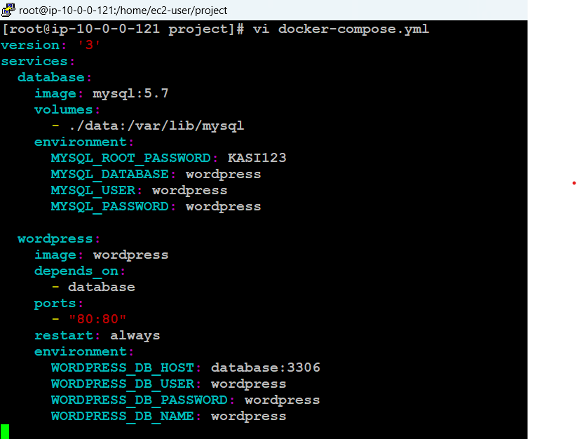

**Breakdown of Configuration:**

**1. Version:**

The file is using version 3 of Docker Compose syntax, which is suitable for most use cases.

**2. Services:**

* **database (MySQL):**
  + **Image:** Uses the official MySQL 5.7 image.
  + **Volumes:** Maps the local ./data directory to MySQL's data directory inside the container (/var/lib/mysql). This allows data persistence.
  + **Environment Variables:**
    - MYSQL_ROOT_PASSWORD: Root password for MySQL (KASI123).
    - MYSQL_DATABASE: The name of the database (wordpress).
    - MYSQL_USER: A non-root user for WordPress to connect with (wordpress).
    - MYSQL_PASSWORD: Password for the WordPress user (wordpress).
* **wordpress:**
  + **Image:** Uses the official WordPress image.
  + **Depends On:** Ensures that the database service starts before WordPress.
  + **Ports:** Exposes the container’s port 80 to the host machine’s port 80, allowing you to access WordPress through http://localhost in your browser.
  + **Restart:** Configures the container to always restart unless explicitly stopped.
  + **Environment Variables:**
    - WORDPRESS_DB_HOST: Hostname and port for the MySQL service (database:3306).
    - WORDPRESS_DB_USER: User for connecting to the database (wordpress).
    - WORDPRESS_DB_PASSWORD: Password for the WordPress database user (wordpress).
    - WORDPRESS_DB_NAME: The name of the WordPress database (wordpress).

**Steps to Run:**

1. **Create the Docker Compose File:**
   * Save the provided YAML configuration as docker-compose.yml in your project directory.
2. **Start the Services:**
   * Open a terminal and navigate to the directory where the docker-compose.yml file is located.
   * Run the following command to start the containers:

bash

Copy code

docker-compose up

1. **Access WordPress:**
   * Once the containers are up and running, open a web browser and navigate to http://localhost.
   * You should see the WordPress setup page. Follow the on-screen instructions to complete the installation.
2. **Stopping the Containers:**
   * To stop the containers, press Ctrl+C in the terminal or run:

bash

Copy code

docker-compose down